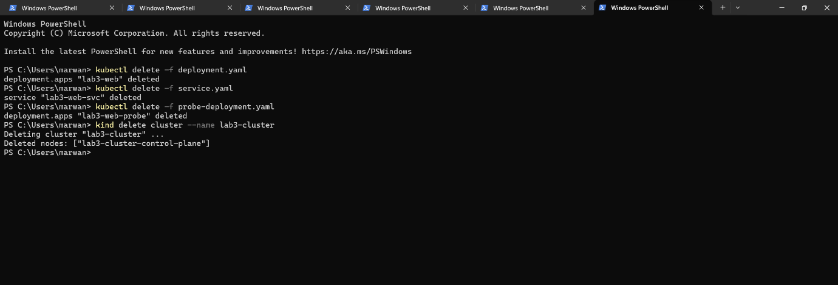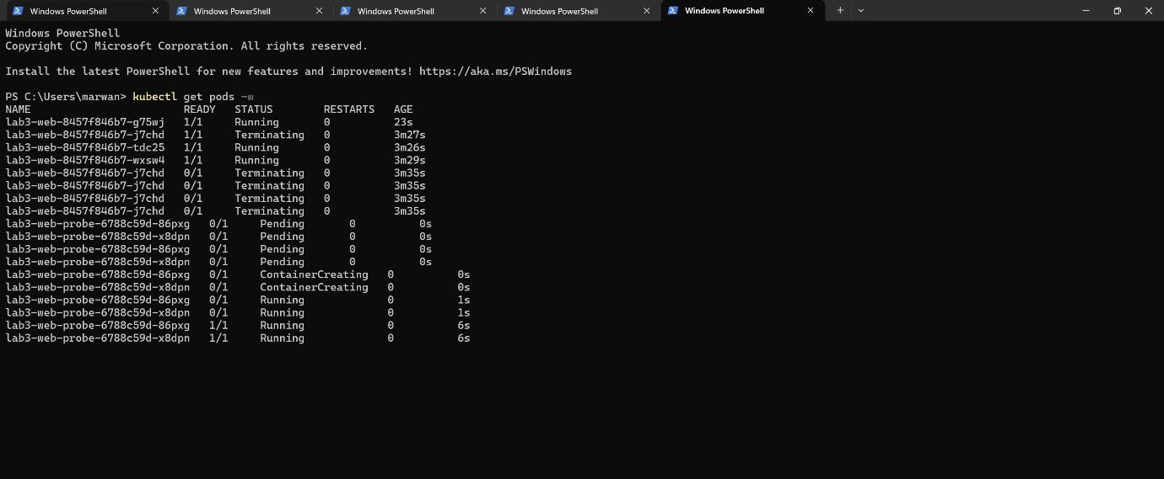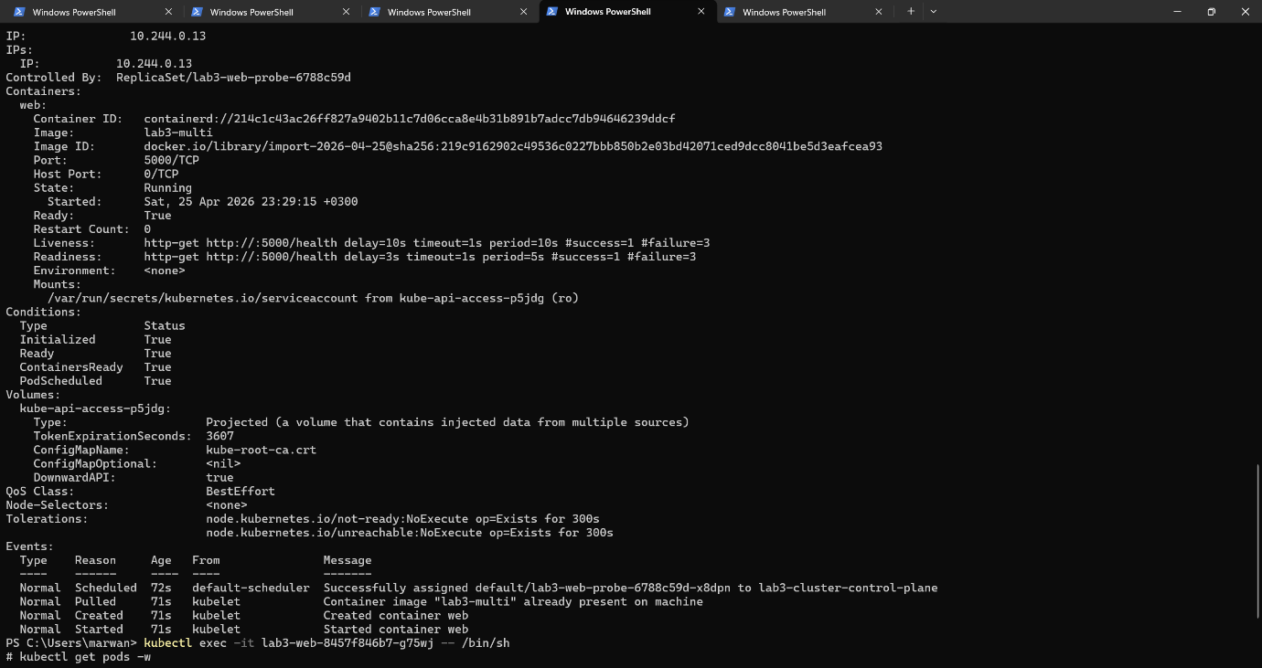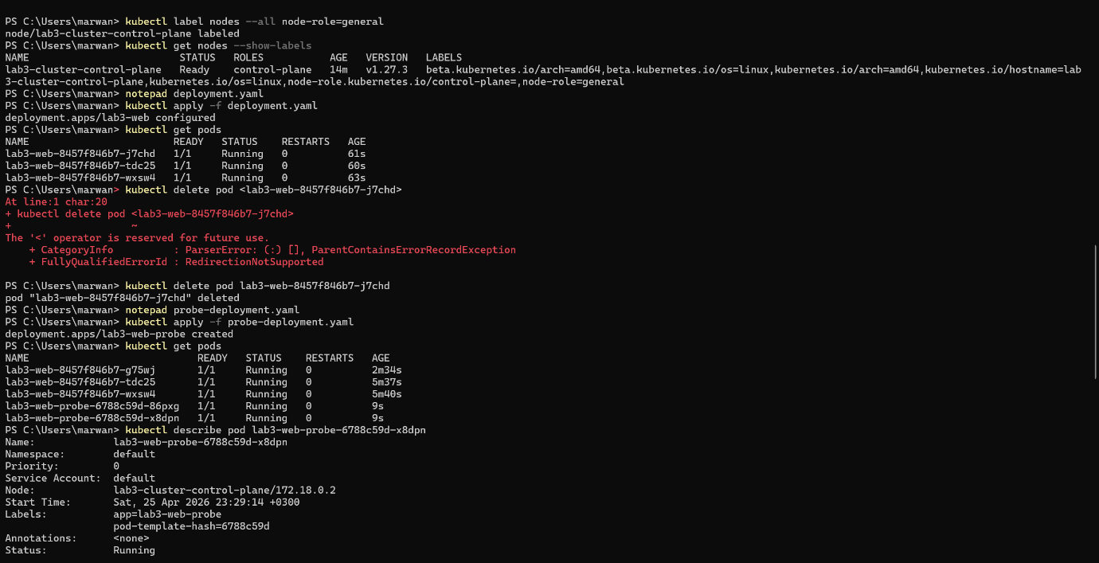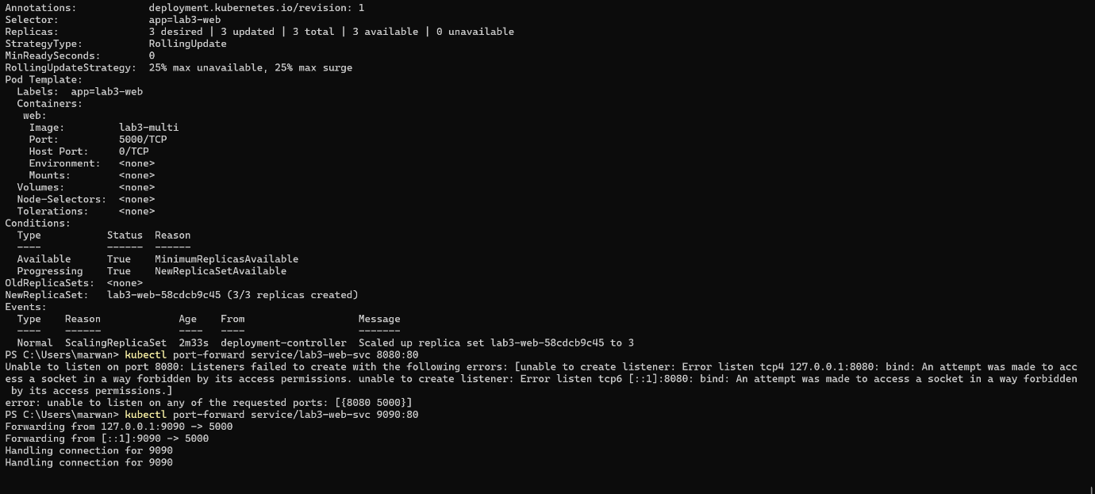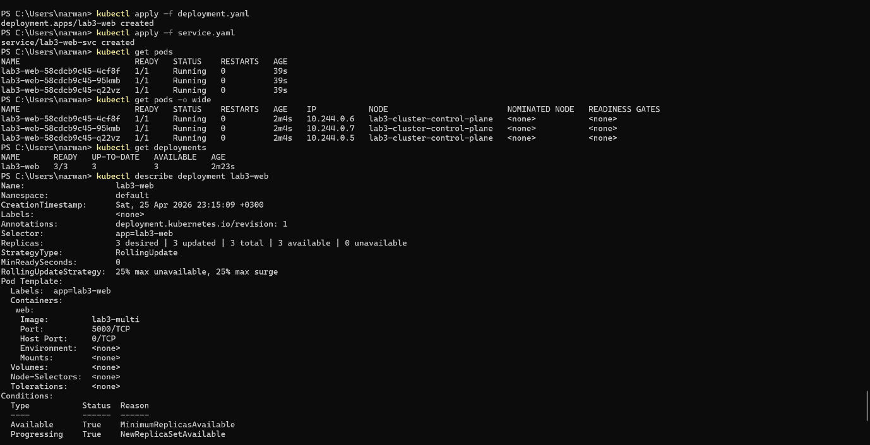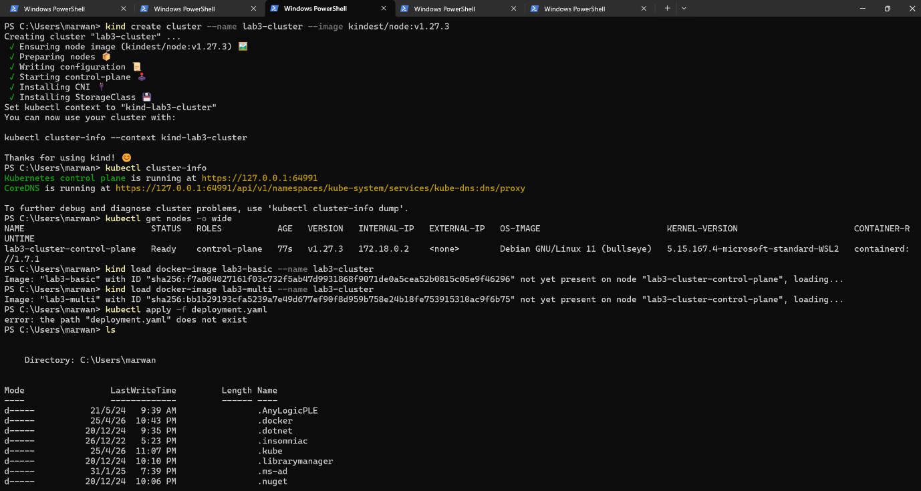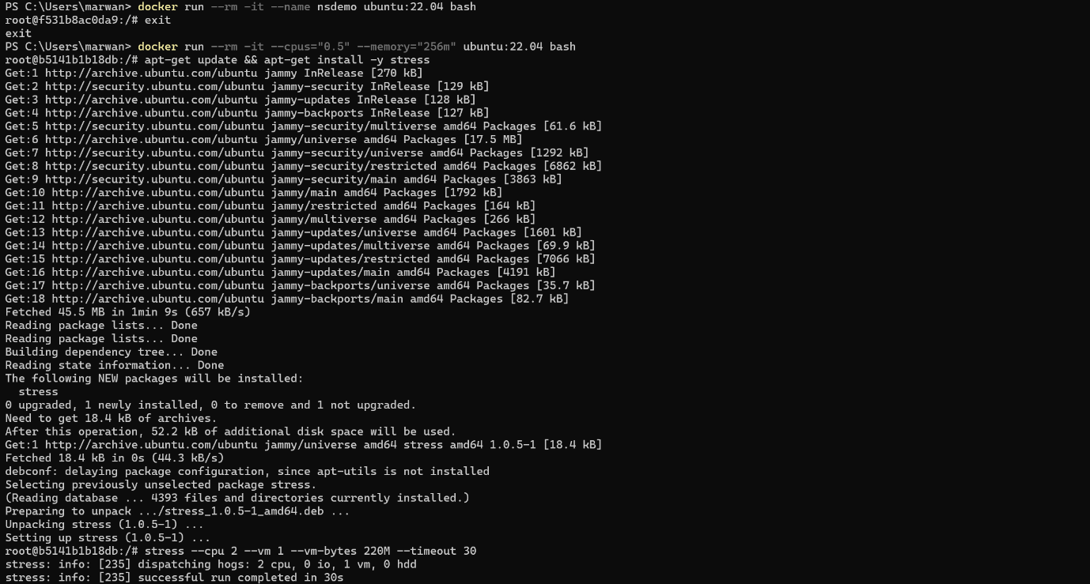

• Containers are just restricted programs: Namespaces isolate what the program can see, while cgroups limit how much memory or CPU it can actually use. Together, they keep your apps from hogging the computer's resources.
• Docker Layers save time: Building images in layers affects speed and storage. It is like building with Lego blocks—if you only change your code at the top, Docker reuses the heavy installation layers at the bottom. This makes updates incredibly fast.
• Kubernetes is a tireless manager: You simply declare your "desired state" (like "I want exactly 3 web servers running"). You do not micromanage which specific machine runs them; the system figures out the best placement using simple tags and labels.
• Self-Healing: If a container crashes, the orchestration platform immediately reacts to the failure. It automatically creates a replacement to match your desired state, meaning nobody has to wake up at 3 AM to fix a broken server.
• Checking the pulse (Probes): Liveness probes check if an app has frozen and needs to be forcefully restarted. Readiness probes check if the app is just busy or booting up, temporarily pausing traffic to it until it is ready

